| Sepal length | Sepal width | Petal length | Petal width |
| --- | --- | --- | --- |
| 5.0 | 3.4 | 1.5 | 0.2 |

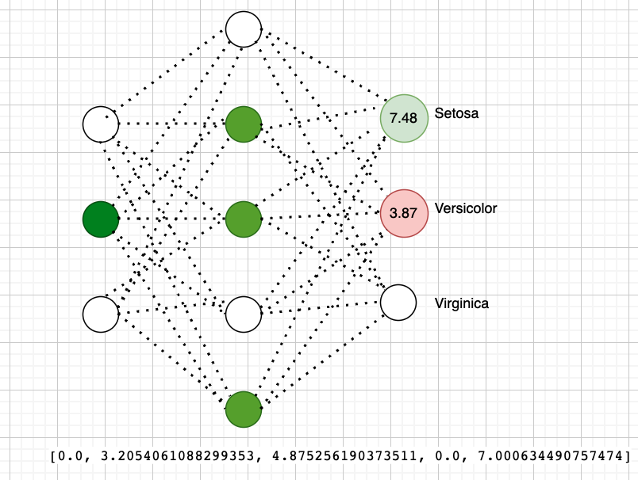

| Sepal length | Sepal width | Petal length | Petal width |
| --- | --- | --- | --- |
| 4.01 | 2.41 | 2.49 | 1.19 |

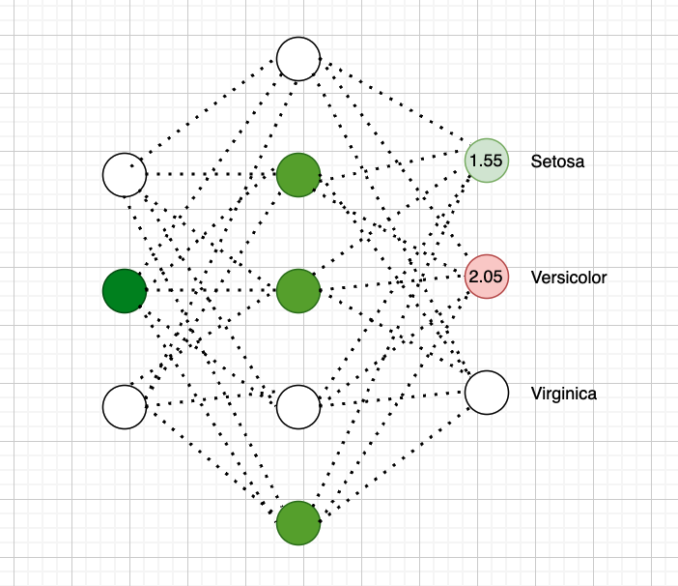

[0.0, 0.4916184313899853, 1.5838163304749455, 0.0, 2.2743612336462795]

| Sepal length | Sepal width | Petal length | Petal width |
| --- | --- | --- | --- |
| 4.01 | 2.41 | 2.3 | 0.8 |

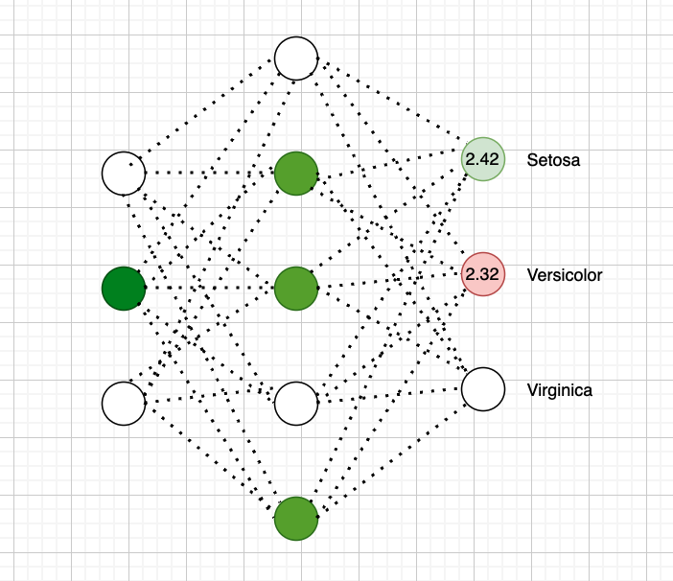

[0.0, 0.8911994807413203, 2.0684515154706156, 0.0, 2.9702628486831593]

| Sepal length | Sepal width | Petal length | Petal width |
| --- | --- | --- | --- |
| 4.01 | 2.41 | 2.4 | 0.8 |

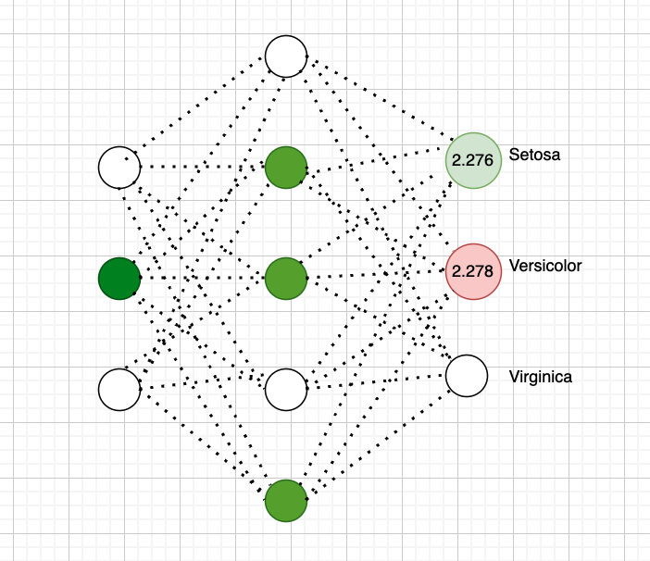

[0.0, 0.8214865657199343, 1.9838996291316044, 0.0, 2.848852360795743]

| Sepal length | Sepal width | Petal length | Petal width |
| --- | --- | --- | --- |
| 4.01 | 2.41 | 2.4 | 0.9 |

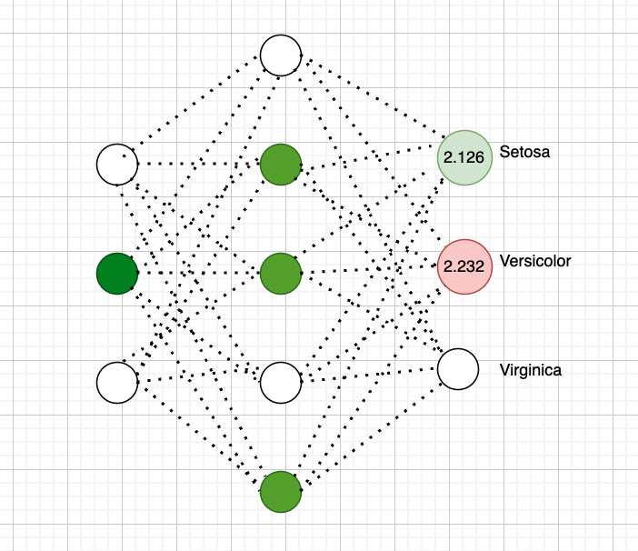

[0.0, 0.7529925885889853, 1.9008261417081305, 0.0, 2.729564748475028]

4.8 3.0 1.4 0.3

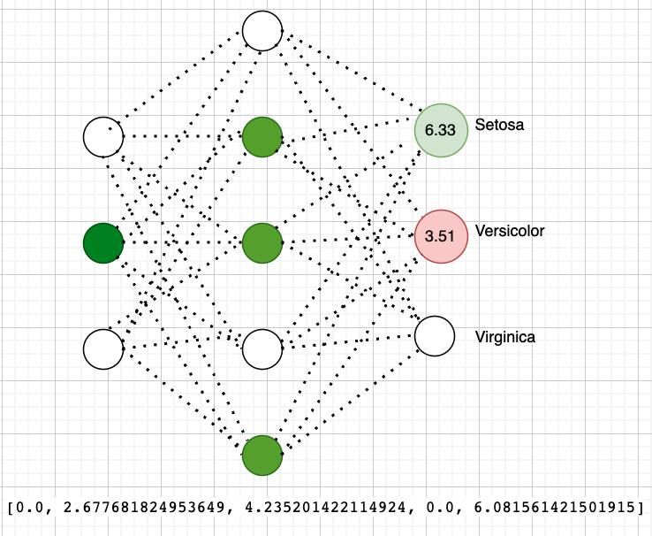

| 5.1 | 3.8 | 1.6 | 0.2 |
| --- | --- | --- | --- |

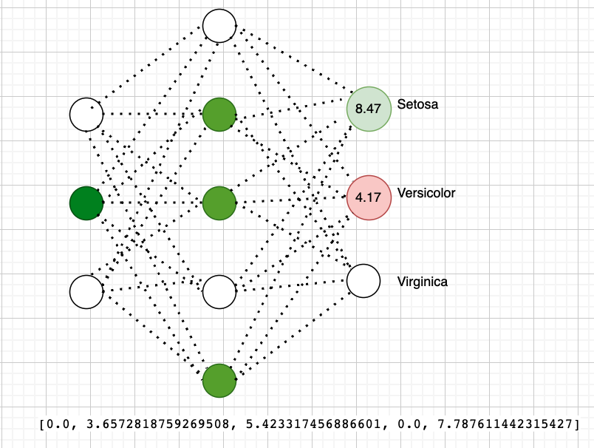

|  | 4.6 | 3.2 | 1.4 | 0.2 |
| --- | --- | --- | --- | --- |

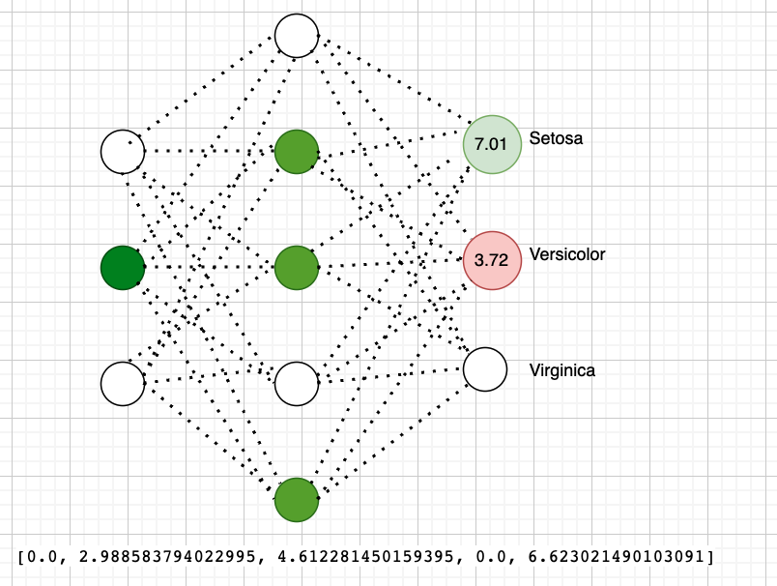

| 4.4 | 3.2 | 1.3 | 0.2 |
| --- | --- | --- | --- |

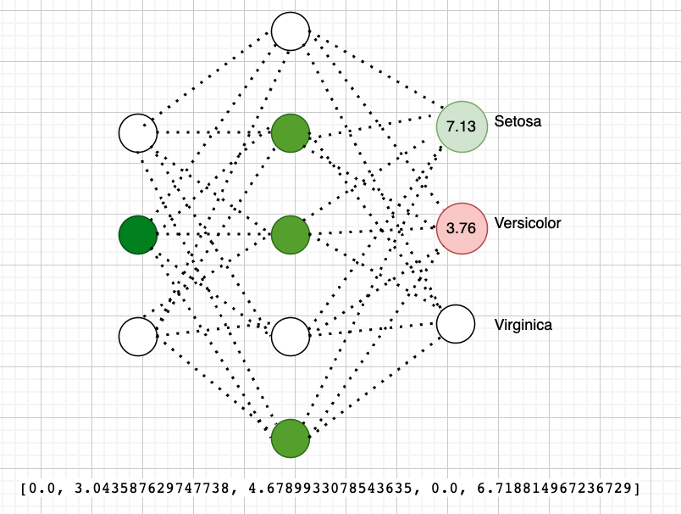

| 7.0 | 3.2 | 4.7 | 1.4 |
| --- | --- | --- | --- |

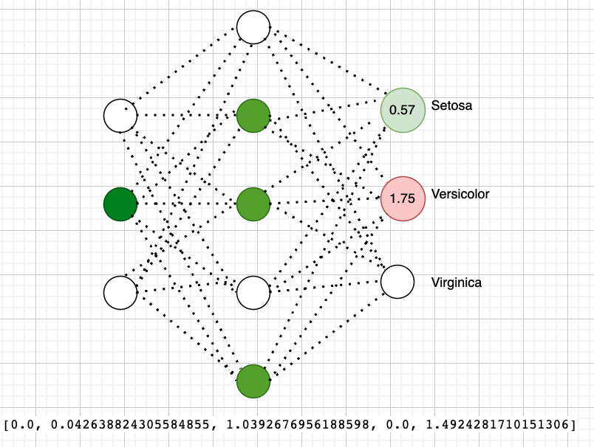

| 6.3 | 3.3 | 4.7 | 1.6 |
| --- | --- | --- | --- |

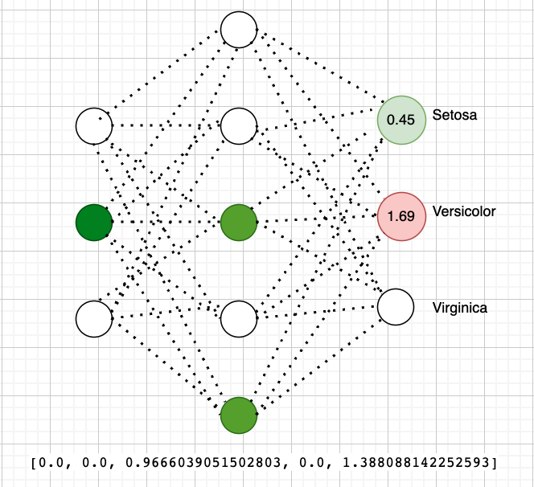

| 6.6 | 2.9 | 4.6 | 1.3 |
| --- | --- | --- | --- |

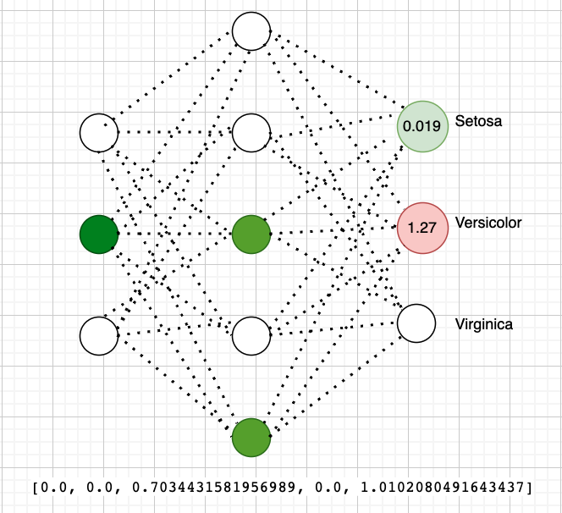

| 7.6 | 3.0 | 6.6 | 2.1 |
| --- | --- | --- | --- |

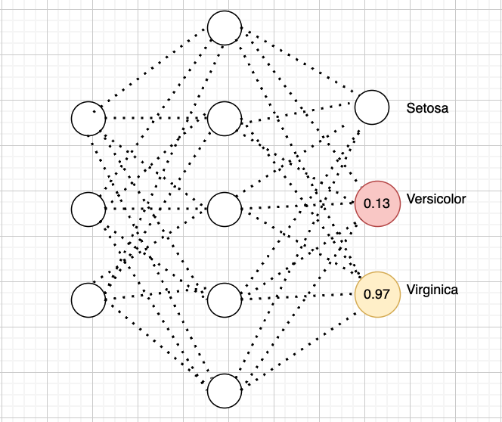

| 4.9 | 2.5 | 4.5 | 1.7 |
| --- | --- | --- | --- |



| 7.3 | 2.9 | 6.3 | 1.8 |
| --- | --- | --- | --- |



6.0 2.9 4.5 1.47 // Perfectly classified as versicolor

